Lab - Build a Simple Network

# Topology

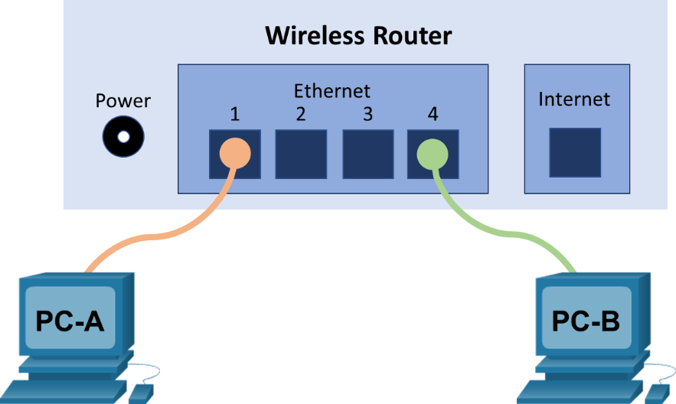

# Addressing Table

| Device | Interface | IP Address | Subnet Mask |
| --- | --- | --- | --- |
| PC-A | NIC | 192.168.1.10 | 255.255.255.0 |
| PC-B | NIC | 192.168.1.11 | 255.255.255.0 |

# Objectives

Part 1: Set Up the Network Topology (Ethernet only)

* Identify cables and ports for use in the network.
* Cable a physical lab topology.

Part 2: Configure PC Hosts

* Enter static IP address information on the LAN interface of the hosts.
* Verify that PCs can communicate using the ping utility.

# Background / Scenario

Networks are constructed of three major components: hosts, switches, and routers. In this lab, you will build a simple network with two hosts and a wireless router with at least two switchports. You will apply IP addressing for this lab to the PCs to enable communication between these two devices. Use the **ping** utility to verify connectivity.

# Required Resources

* 1 wireless router with at least two switchports
* 2 PCs running Windows with wired network cards installed
* 2 Ethernet patch cables

# Instructions

## Set Up the Network Topology (Ethernet only)

In Part 1, you will cable the devices together according to the network topology.

### Power on the devices.

Power on all devices in the topology.

### Connect the PCs to the switch.

* + - 1. Connect one end of an Ethernet cable to the NIC port on PC-A. Connect the other end of the cable to a switchport on the wireless router. After connecting the PC to the switchport, you should see the light for the switchport turn amber and then green, indicating that PC-A has been connected correctly.
      2. Repeat the same procedure for PC-B.

**Step 3: Visually inspect network connections.**

After cabling the network devices, take a moment to carefully verify the connections to minimize the time required to troubleshoot network connectivity issues later.

## Configure PC Hosts

In this lab, all the network configurations are done on a Windows 10 PC.

### Configure static IP address information on the PCs.

* + - 1. To configure the Network Settings on PC-A, click **Start**, then click **Settings**.
      2. In the Settings window click **Network & Internet**.
      3. In the left pane select **Ethernet**, then click **Change adapter options**.
      4. The Network Connections window displays the available network interfaces on the PC. Right-click the **Ethernet0** interface and select **Properties**.
      5. Select the **Internet Protocol Version 4 (TCP/IPv4)** option and then click **Properties**.

**Note**: You can also double-click **Internet Protocol Version 4 (TCP/IPv4**) to display the Properties window.

* + - 1. Click the **Use the following IP address** radio button to manually enter an IP address, subnet mask, and default gateway. Type in the IP address 192.168.1.10 and the subnet mask 255.255.255.0

**Note**: In the above example, the IP address and subnet mask have been entered for PC-A. The default gateway has not been entered because the router is not configured. Refer to the Addressing Table on page 1 for PC-B’s IP address information.

* + - 1. After all the IP information has been entered, click **OK**. Click **OK** on the Ethernet0 Properties window to assign the IP address to the LAN adapter. Click **Close** to close the Ethernet0 Status window.
      2. Repeat the previous steps to enter the IP address information on PC-B.

### Verify PC settings and connectivity.

Use the Command Prompt to verify the PC settings and connectivity.

* + - 1. From PC-A, click **Start** and search for **Command Prompt**.
      2. The Command Prompt window is where you can enter commands directly to the PC and view the results of those commands. Verify your PC settings by using the **ipconfig /all** command. This command displays the PC hostname and the IP address information.
      3. Type **ping 192.168.1.11**.

#### Question:

Were the ping results successful?

Type your answers here.

If the ping was unsuccessful, there is good chance that **Windows Firewall** is blocking ICMP echo requests (ping). Click **Start** > **Settings** > **Network & Internet** > **Ethernet** > **Windows Firewall** to turn it off. For security purpose, you should return the firewall back to the original state when you are finished with the lab.

**Note**: If you did not get a reply from PC-B, try to ping PC-B again. If you still do not get a reply from PC-B, try to ping PC-A from PC-B. If you are unable to get a reply from the remote PC, ask your instructor to help you troubleshoot the problem.

End of document